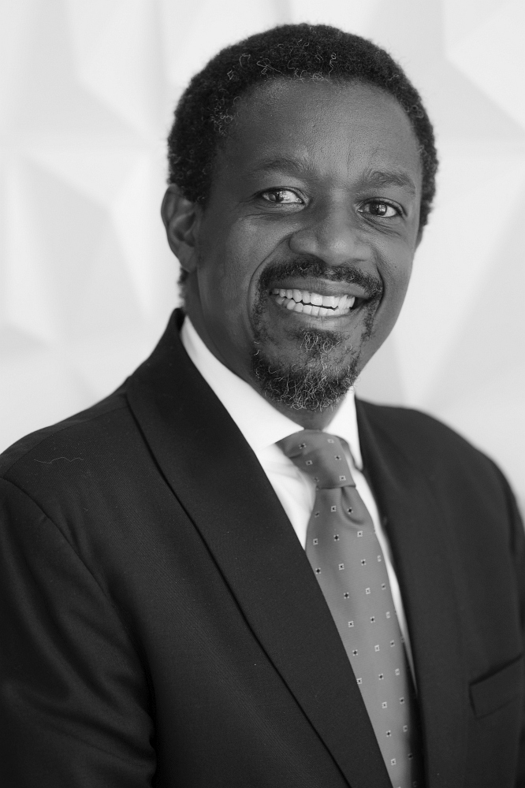
SECHABA MOTSIELOA

B.Soc.Sci -1995
University of Cape Town (Industrial & Organizational Psychology and Economics)

B.Soc.Sci (Hons) -1996
University of Cape Town, (Organizational Psychology)

Msc -Management of Technology and Innovation
Da Vinci Institute (In progress)

Professional Designation – Chartered Marketer (CM(SA))

CONTACT DETAILS
Cell 082 570 0246 or 082 552 8137
E-mail sechabam@kansygroup.com
E-mail (cc) motsieloa.sechaba@gmail.com

7 Balmoral Street Postnet Suite 38
Midstream Estate Private Bag X 43
Midrand Sunninghill
1692 2157

OVERVIEW

Sechaba is a Managing Partner at the Kansy Group (which he co-founded with Yolanda Motsieloa in June 2018). Kansy Group is a Consulting and Coaching Company focussing on a Oneness Approach to Business and Life. He consults on Strategic Marketing, Strategic Communication (internal and external), Brand Management and Reputation Management. As a Oneness Approach Coach, he coaches, mentors and advises business leaders, marketers and students.

Sechaba completed B.Soc.Sci (Hons) in Organisational Psychology in 1996. He holds the Chartered Marketer (CM(SA)) designation and is currently studying towards an MSc (Management of Technology and Innovation). He is an internationally experienced professional who passionately and courageously brings to business his gifts of marketing, branding, communication, reputation management, and overall leadership. His overarching gift is his ability to detach and step back, connect dots and see a pattern in scenarios that seemed separate and unrelated. He has an astounding ability to see beyond obvious scenarios. Throughout his career he has used these gifts in the various roles at SFW, SAB, Kimberly Clark, McDonald’s, Magna Carta and Lurco Group.

For the past 20 years, Sechaba has held management and leadership positions in a number of companies and organisations. He currently serves as non-executive director on the boards of Marketing Association of South Africa (serving as Chairman), Professional Designation Board for Chartered Marketers and is Guarantor of the ABC (Audit Bureau of Circulation of SA). He serves as Chairman of Council at the Da Vinci Institute, an accredited provider of Higher Education. He previously served on the McDonald’s South Africa Board.

My value propostion and Personal Attributes

My Unique Being Proposition (UBP) is true to my name, Sechaba, which is a ‘Nation in one and all’, as I see beyond the seemingly obvious, I connect the dots and see ‘oneness’ in All.

I seek to make the institutions that I work for, and with, successful on three dimensions, knowing that through serving others, I serve myself:
  - strong financial performance
  - positive impact in society
  - being good to the environment

Experience and Specialised Skills

Founding Member and Managing Partner at KANSY GROUP: July 2018 – ongoing

- Consulting
  - Strategic Marketing to help marketing leads to turn business strategy into marketing strategy and to define their organization’s ‘marketing way’. To constantly innovate around this and to demonstrate return on marketing investment (ROMI) through rigorous and reliable data to show marketing’s contribution to the business’s financial performance.
  - Strategic Communication (internal and external) to get alignment behind the business’s strategic priorities and long-term vision.
  - Brand Management fundamentals to guide and direct brand positioning and meaning. Also to create an environment where ideas, informed by customer and market insights, drive marketing excellence and business performance.
  - Reputation Management to enhance, protect and promote the brand and the corporate image.
- Coaching companies on a Oneness Approach to Business and Life
  - Providing guidance to individuals and businesses to stay connected to their purpose and vision, and providing tools to keep the alignment.
  - Coaching individuals to increase their impact by understanding themselves and the other within a shifting context.
  - Coaching and guiding individuals and businesses to see the bigger picture and always staying in a vantage point that allows everyone to connect the dots to see the Whole
  - Helping individuals to adapt and successfully transition between work roles
  - Guiding individuals to optimise their contribution by BEING their essence and living it.

